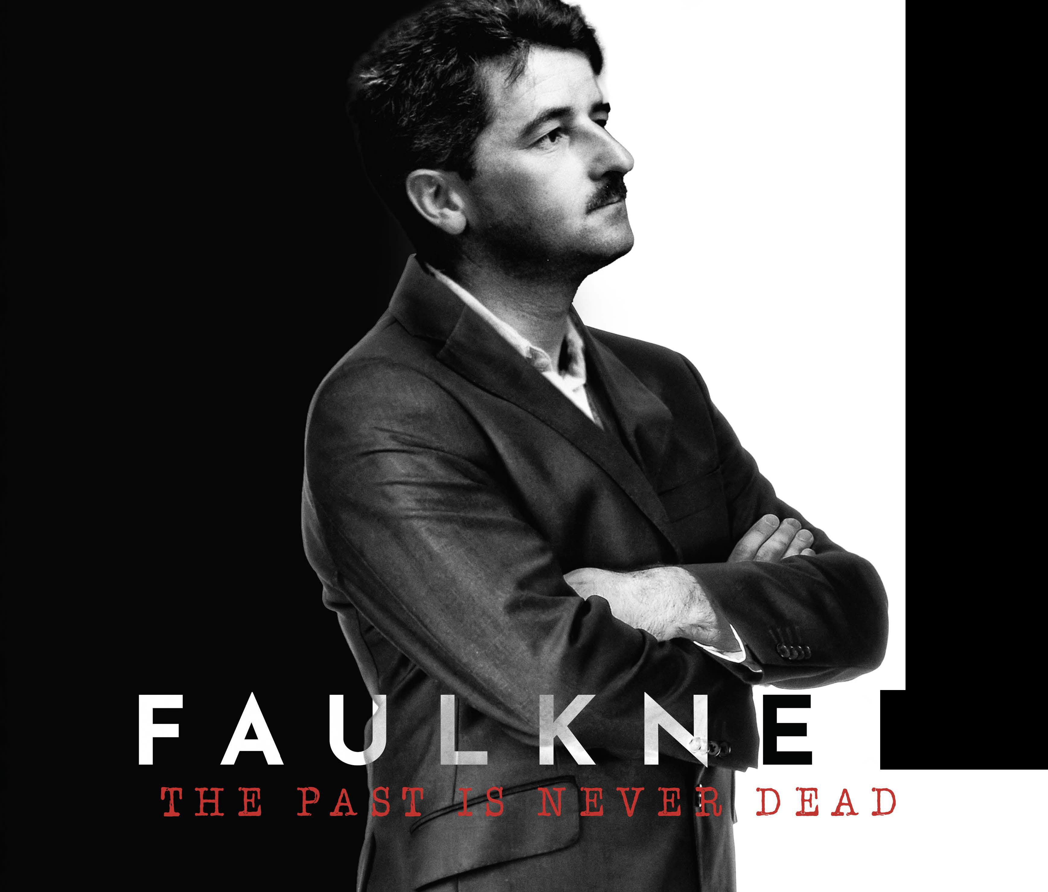

Press Contact
Anita Modak-Truran
Anita.modaktruran@gmail.com
(601) 201-5783

CREATIVE TEAM

MICHAEL MODAK-TRURAN
Writer-Director-Producer
Favorite Faulkner Quote:

“Art is not only mankind's supreme expression;
it is also the salvation of mankind."

As a filmmaker, I firmly believe that art "is the salvation of mankind." Through art we are able to bridge different perspectives and find our commonalities.
​ After growing up in Mississippi, graduating from the University of Chicago and working as a non-profit consultant, I started working full time on this documentary. As a millennial, I wasn't sure if I could relate to Faulkner. There were things he reportedly said that I didn't like, and still struggle to completely understand. But during my journey into Faulkner's life and work, I was able to find commonality. Faulkner didn't seek fame or grand adventure like some of his contemporaries. Faulkner's writing was his salvation. His work demonstrated the inner conflict of the social tensions of his times -- and ours.
​
ANASTASIA LAMPTON TRIPLETT
Producer
Favorite Faulkner Quote:
"Loving all of it even while he had to hate some of it because he knows
now that you don't because: you love despite; not for the virtues, but
despite the faults."

I like this quote because it reflects on the complex personality and dark history of Mississippi, this country and all other nations. There are so many beautiful things about who we are, but yet so many faults from our past we still face today. By challenging our virtues through hard conversations as a community, I think we can start chipping away at our faults.​
​ Having worked in entertainment law, I was ready for the creative side of producing when offered this opportunity. Michael and I started interviewing Faulkner scholars in 2017. The two of us did everything, and while it started small, it grew quickly and so did our amazing team. It has been an exciting journey, and I have found that Faulkner is more relevant to today's conversations than ever before.
​

JEREMY CULVER
Producer
Favorite Faulkner Quote:
"You cannot swim for new horizons until you have courage to lose sight of the shore."

In art as in life, it takes courage to explore the deep questions inside one's soul. When communities come together to share in these explorations, real growth can take place. Having been born in Hawaii and raised in multiple states, followed by various stints living overseas, my experiences have both pushed and resulted in my swimming for new horizons. As a filmmaker, I've focused these explorations on the questions of reconciliation and salvation in both a spiritual and temporal context.
Through it all, one journey has seemingly led to the other. This particular journey led to Oxford, MS and Rowan Oak where I was privileged to join an exceptional community of artists and scholars to explore many difficult questions relating to Faulkner.
ANITA MODAK-TRURAN
Executive Producer
Favorite Faulkner Quote:
“Memory believes before knowing remembers. Believes
longer than recollects, longer than knowing each wonders."
​
In this beautiful quote, Faulkner eloquently demonstrates why we view the world differently. The way we remember our past influences and alters our view of the present and future. It's not about truth. It's about the memory of experience, which shapes our personal view of the world.
​
I grew up in a multi-cultural family. My mother is a French-speaking, Roman Catholic from Montreal. My father was a Bengali-speaking, Hindu from Calcutta. I grew up reading French writers and watching Indian cinema. I cherish uniqueness over sameness, probably because I felt so different from my friends.
​ Faulkner was different too, and his community ostracized him for being different. He saw the "human heart in conflict with itself" while others saw only black and white. Faulkner's work crossed cultures because his characters and stories grappled with issues germane to human existence.

INTERVIEWEES AND CONSULTANTS
Professor Jay Watson, the Howry Professor of Faulkner Studies at University of Mississippi, provided us with a framework to understand the writer and the work.
Dr. Molly Schwartzburg, the Curator Special Collections at the University of Virginia, provided us with unfettered access and assistance to the multiple Faulkner collections at University of Virginia.
In addition to Mississippi and Virginia, we traveled to Missouri, Texas, New York and Japan to review archival material. We gathered information from many sources, including Faulkner scholars, academics, writers, librarians, Civil War re-enactors, family, friends and more.
​ Collaborators include, without limitation, the following:
​

- Professor Emeritus Ann Abadi (University of Mississippi)
- Professor Tim Armstrong (University of London)
- Professor Edward Baptist (Cornell University)
- Gloria Burgess (Writer, Poet)
- Lee Caplin (former neighbor of Faulkner and Executor of the Faulkner Literary Trust)
- Christopher Cerf (writer, filmmaker, Grammy winner and son of Random House founder Bennett Cerf)
- Dr. Linda Chavers (Allston Burr Resident Dean of Winthrop House, Assistant Dean of Harvard College)
- John Cofield, Writer
- Dr. Steven L. Cobb (University of North Texas)
- Debra Cohn (University of Indiana)
- Dr. Joanna Davis-McElligatt (University of North Texas)
- Florence Dore (University of North Carolina)
- Dr. Roxanne Dunn (Special Collections/Archives Librarian, Southeast Missouri State University)
- Professor John Duvall (Purdue College)
- Dr. W. Ralph Eubanks (Author, Writer, Essayist, Guggenheim recipient, visiting professor of English and Southern Studies)
- William Ferris (Former Chair of the National Endowment for the Humanities)
- Rusty Faulkner (Faulkner’s nephew)
- Amy Anne Foley
- Professor Sarah Gleeson-White (University of Sydney, Australia)
- William Griffith (Curator of Rowan Oak)
- Professor Richard Godden (Professor of Suffix)
- Professor Michael Gora (Smith College)
- Professor Emeritus Robert Hamlin (Founding Director of the Center for Faulkner Studies, Southeast Missouri State University)
- John Henegan (lawyer)
- Professor Emeritus Jere Richmond Hoar (University of Mississippi)
- Richard Howorth (owner of Square Books, Oxford, MS)
- Dr. Greg Johnson (Special Collections at University of Mississippi)
- Professor Sherita Johnson (University of Southern Mississippi)
- Daniel P. Jordan, Ph.D. (Faulkner friend and former head of the Thomas Jefferson Foundation)
- Randall Kenan (award winning author)
- Professor Heidi Kim (University of North Carolina)
- Professor John T. Matthews (Boston University)
- Professor Kim Manganelli (Clemson University)
- John Maxell (actor and performer of award winning one man show on William Faulkner)
- Jane McLarty (friend of Faulkner)
- Luther Munford (lawyer)
- Dr. Julie Beth Napolin (Eugene Lang College of Liberal Arts)
- Professor Eiko Owada (University of Tokyo)
- Professor Tom Rankin (Duke University)
- Professor Steve Railton (University of Virginia)
- Professor Carl Rollyson (Baruch College, City University of New York)
- Professor Christopher Rieger (Director of Center for Faulkner Studies, Southeast Missouri State University)
- Robert Saarino (Director of Mississippi University Museums)
- Dr. Molly Schwartzberg (Curator of Special Collection, University of Virginia)
- Professor Elizabeth Spenser (Morehead State University)
- Paul Summers (Faulkner’s grandson)
- Professor Takako Tanaka (Nagoya City University, Japan)
- Professor Jay Watson (Director of the Faulkner & Yoknapatawpha Conference, University of Mississippi)
- Dr. Laura Wilson (Fisk University)
- Professor Yuko Yamamoto (Chiba University, Japan)

