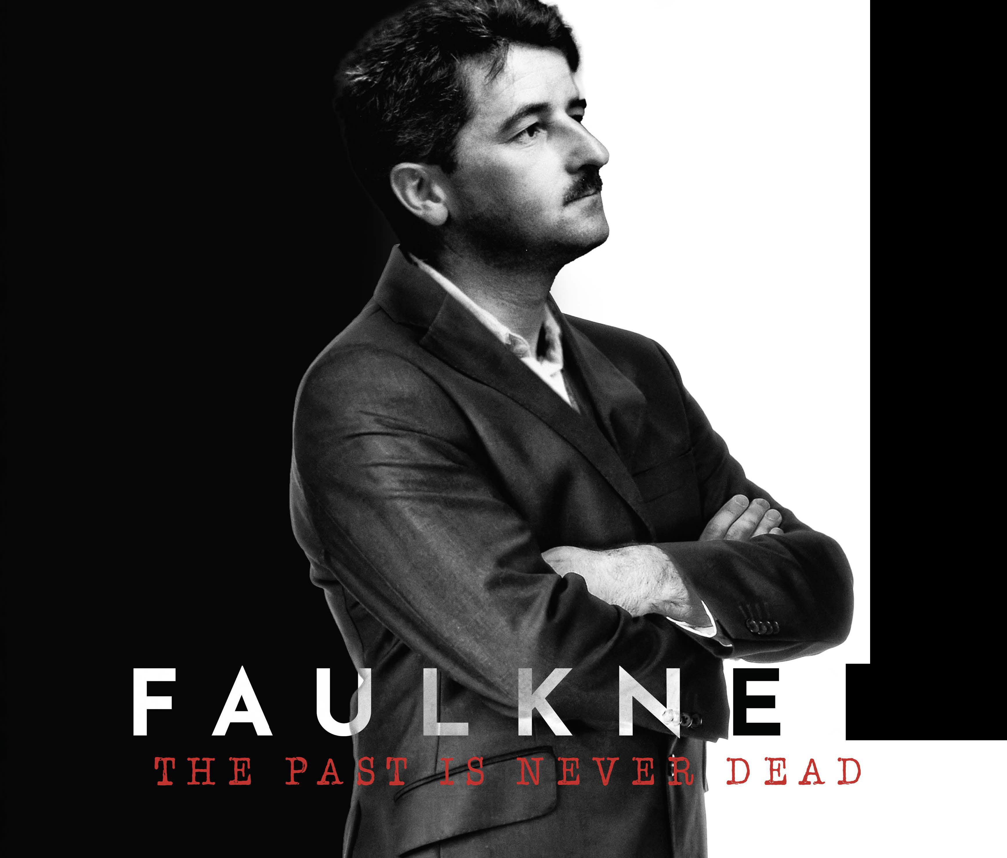

Press Contact
Anita Modak-Truran
Anita.modaktruran@gmail.com
(601) 201-5783
STORYLINE
Narrated by Academy Award nominee Eric Roberts, "Faulkner: The Past Is Never Dead" is about the Nobel-prize writer William Faulkner who has not only shaped the American literary canon but also America's conversations about race. Faulkner's "unflinching gaze" examines issues of race relations, equality, and civil rights-themes that speak powerfully to modern day. Born to a family of segregationists, Faulkner manages to confront his views about Black Americans and racial equality in his literary works. He includes more Black characters than his contemporary white writers and depicts them with a level of specificity unmatched at the time.
However, how much was Faulkner able to escape his past?
How should modern audiences approach a sometimes problematic subject? The film situates these questions in a rich telling of Faulkner’s story that combines historically accurate re-enactment scenes created using Faulkner's words, animated recreations of Faulkner's literary world and drawings, and conversations with Faulkner's family and the world's leading experts.

