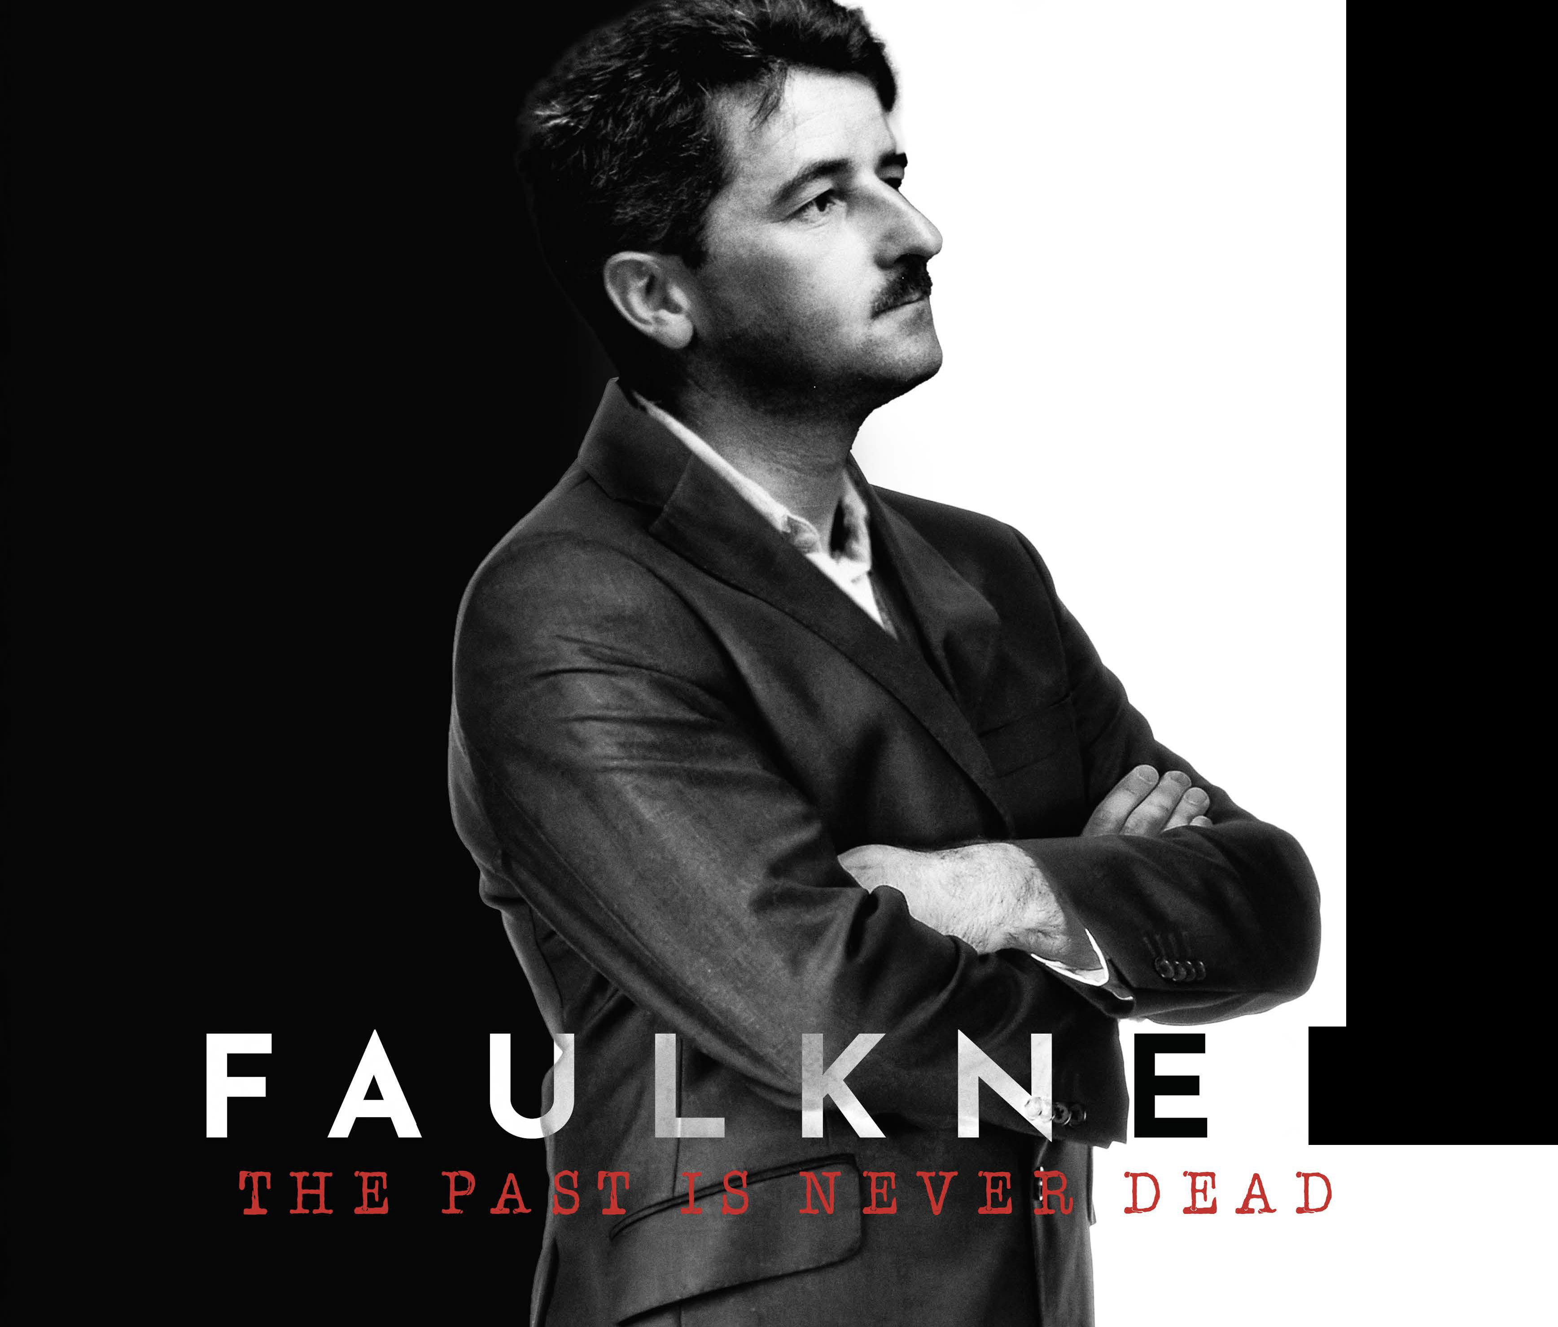

Press Contact
Anita Modak-Truran
Anita.modaktruran@gmail.com
(601) 201-5783

DIRECTOR’S STATEMENT
To depict Faulkner’s journey, I have had to contend with the relatively little archival visual material that Faulkner left behind. However, I view this constraint as an opportunity for a more innovative, hybrid documentary approach that marries traditional interviews, archival media, animated sequences, and re-enacted scenes.
Interviews with leading academics, Faulkner descendants, and others explore Faulkner’s writing influences, life, literary style, and personae. Archival photographs, video, and documents provide visuals for their stories.
Woven into the interview commentary are re-enacted scenes that form the narrative ark of the film. These scenes build from Faulkner and his contemporaries’ words in Faulkner’s literature, letters, and life. Like Faulkner’s Absalom, Absalom!, multiple narrators come together to tell the story.
In everything from its approach to content, The Past is Never Dead aspires to inculcate a new generation of Faulkner readers and fans. The Mississippi-and-millennial-rooted crew hopes to use their backgrounds in documentary technique, narrative film and television, history, academic research, and music to remind audiences of Faulkner’s continued relevance—how his past is not yet dead.
​
- Michael Modak-Truran

